Data base reference location:

https://github.com/richardsforu/cts-adm-microservices-b2/blob/master/db-dump/pss.sql

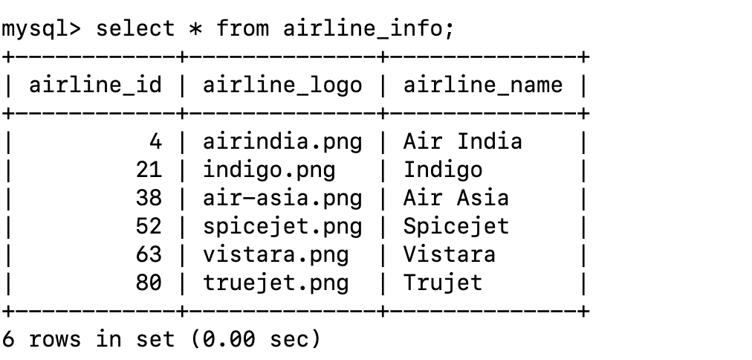

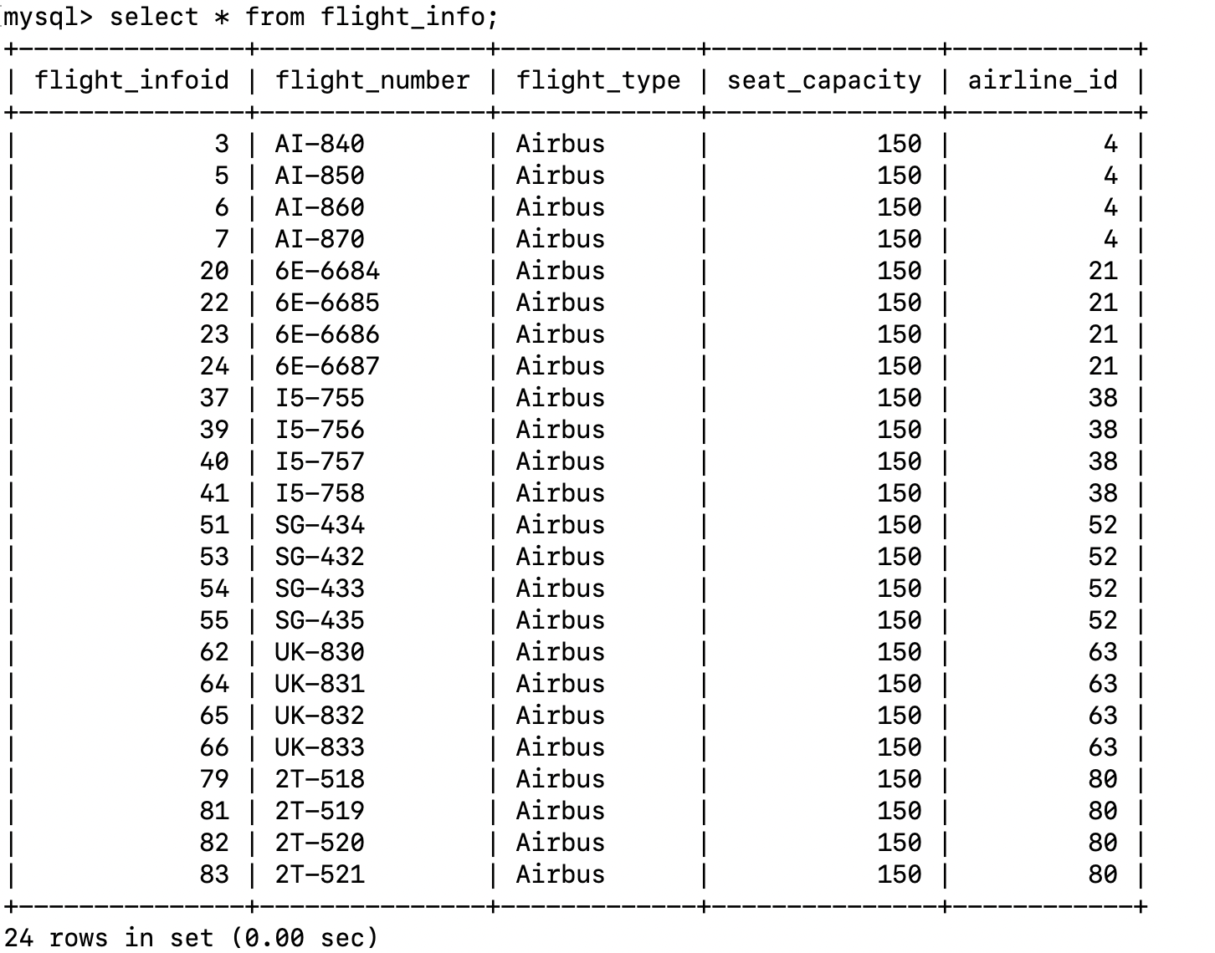

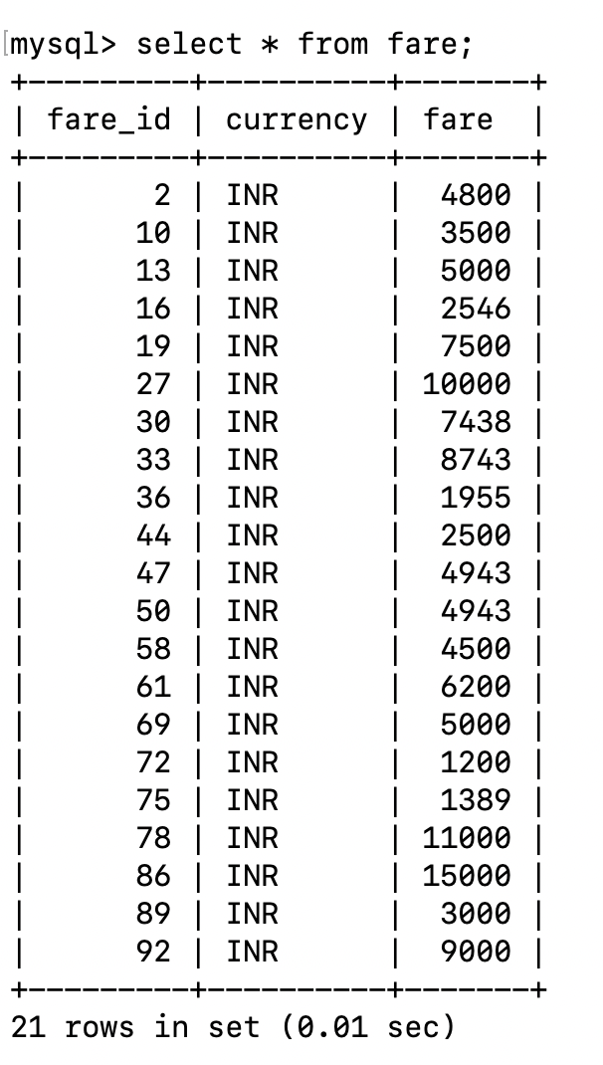

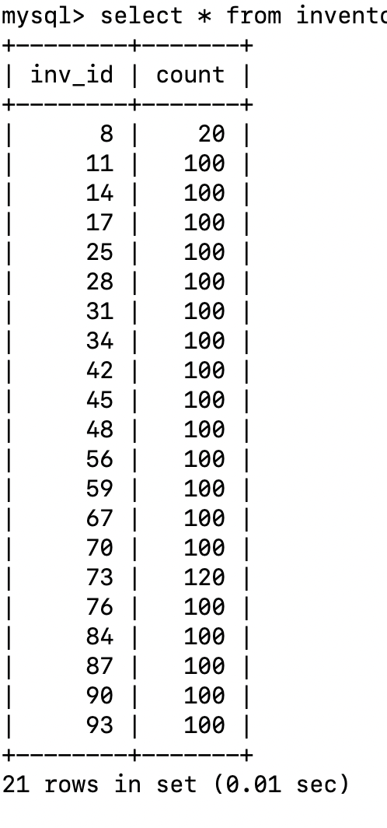

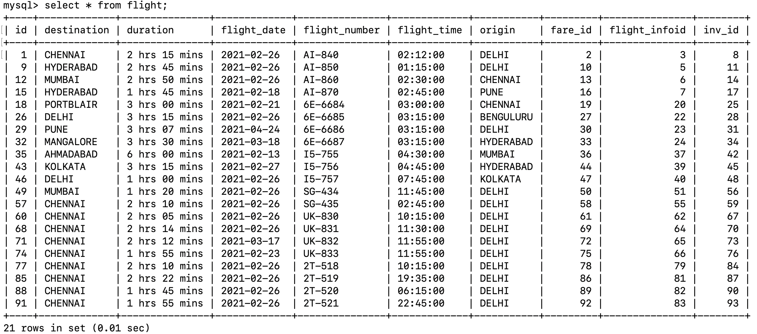

1. List all flights flying from DELHI to CHENNAI on 2021-02-26
2. List all flights flying from DELHI to CHENNAI on 2021-02-26 whose flights having more than 40 seats
3. Find a flight with flight number AI-840 whose is flying from DELHI to CHENNAI on 2021-02-26
4. List all Airindia flights with flight information